SATISH CHANDRA MEMORIAL SCHOOL
PRE MID-TERM EXAMINATION 2025-26
CLASS VII
SCIENCE

Time allowed: 1.5 hours Maximum marks: 40

GENERAL INSTRUCTIONS:

1. Total 34 Questions in Paper for 40 marks
2. Question no. 1 to 10 MCQ Case study-based carries 1 mark each. (Section A)
3. Question no. 11 to 30 are MCQs and carry 1 mark each. (Section B)
4. Question no. 31 to 33 carries 2 marks each. (Section C)
5. Question no. 34 carries 4 marks (Section D)

SECTION A

Read the following case studies and answer the questions given below:

- Ravi is a farmer who noticed that his crops were not growing well despite regular watering and using fertilizers. He approached the local agricultural officer, who advised him to test the pH of his soil. On testing, Ravi found that the soil’s pH was around 4.5.
The officer explained that this soil can harm plant roots and reduce the availability of important nutrients. The officer suggested adding slaked lime (calcium hydroxide) to the soil. Slaked lime is a mild base that helps to neutralise the soil, making it more suitable for growing crops.
After applying the recommended amount of slaked lime, Ravi observed that over a few weeks, the crops started growing better and the plants looked healthier.

1. What is the reason Ravi’s crops were not growing well initially?
- The soil was too dry
- The soil was too acidic
- The soil had too much water
- The soil had excess base

2. Which property of slaked lime helped in improving Ravi’s soil condition?
- It increased the water content of the soil
- It absorbed nutrients from the soil
- It neutralised the excess acid in the soil
- It provided more sunlight to the plants

3. Which of the following best describes the reaction between slaked lime and acidic soil?
- Displacement reaction
- Combination reaction
- Neutralisation reaction
- Decomposition reaction

4. Why is it important to adjust the pH of the soil for crops?
- To improve soil colour
- To help plant roots absorb nutrients properly
- To stop water evaporation
- To prevent insects from entering the soil

5. What is the pH range of a substance considered strongly acidic (like Ravi’s soil)?
- 7–14
- 8-14
- 8–10
- 4–6

II. During the summer holidays, Nisha and her friends went for a picnic at the seaside. In the afternoon, Nisha noticed that the metal handle of their lunch box felt extremely hot, while the wooden handle of the basket was comfortable to touch, even though both were kept under the same sun.
Meanwhile, they enjoyed a cool sea breeze blowing towards the land, making the hot afternoon feel pleasant. Their teacher, who accompanied them, explained to them the conduction of heat.
The teacher also explained that the sea breeze occurs because land heats up faster than water during the day. The warm air over land rises, and cooler air from the sea rushes in to replace it — an example of convection current in action.

6. Why did the metal handle of the lunch box feel hotter than the wooden handle?
- Metal is a poor conductor of heat
- Wood absorbs more heat than metal
- Metal conducts heat quickly
- Metal reflects sunlight into the wood

7. Which method of heat transfer explains why metal quickly transfers heat to the hand?
- Conduction
- Convection
- Radiation
- Insulation

8. Why does the sea breeze blow from the sea to the land during the day?
- Sea heats up faster than land
- Land heats up faster than sea, and warm air over land rises causing sea air to move towards land
- Land cools faster
- Sea air becomes lighter so it moves towards the land

9. Which of the following materials is similar to wood in terms of its heat conduction property?
- Aluminium
- Copper
- Plastic
- Steel

10. Which process is responsible for the movement of air during sea breeze formation?
- Conduction
- Convection
- Radiation
- Sublimation
SECTION B

11. Heat causes-
- Change of state
- Expansion
- Change of temperature
- All of these

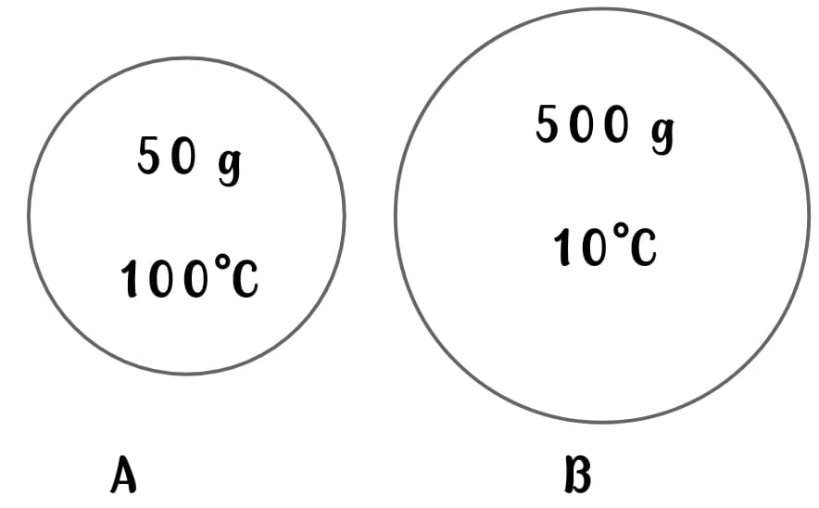
12. In the figure given below, A and B are steel balls. What will be the direction of flow of heat if they are in contact with one another?
- A to B
- B to A
- No heat will flow
- None of these

13. Chlorophyll helps the plants to-
- Exchange gases
- Absorb water from the stem
- Transport food from the leaves to the other parts
- Absorb the sunlight

14. In nature, there are two organisms who happily live together. One prepares the food and the other provides shelter. Their association is called-
- Saprophytic
- Parasitic
- Autotrophic
- Symbiotic

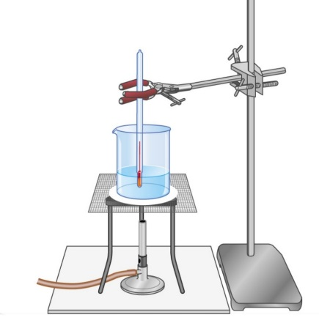
15. A group of students noted the temperature of hot water using a laboratory thermometer. The temperature of the water was 60°C. It is equal to ___°F.

- 104°F
- 141°F
- 140°F
- 144°F

16. How will the addition of turmeric affect the colour of soap solution?
- The solution becomes blue in colour
- The solution becomes red in colour
- The solution becomes yellow in colour
- The solution becomes green in colour

17. A few friends measured their body temperature. The thermometer had readings in Celsius and Fahrenheit. Some recorded their temperature as 98.6⁰F while some recorded as 37⁰C. Which of the following statements is correct?
- Some students have a higher body temperature than others
- Both groups have normal body temperature.
- Students who measured in Celsius have a lower body temperature than others
- Both groups are suffering from fever.

18. DIRECTIONS: On the basis of the following diagram/ picture answer the questions given below: Which of the following will change blue litmus paper to red?
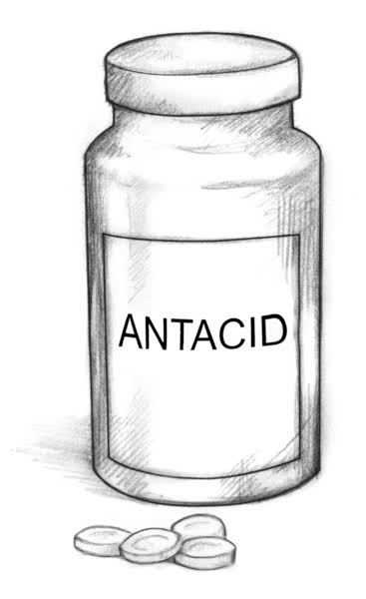
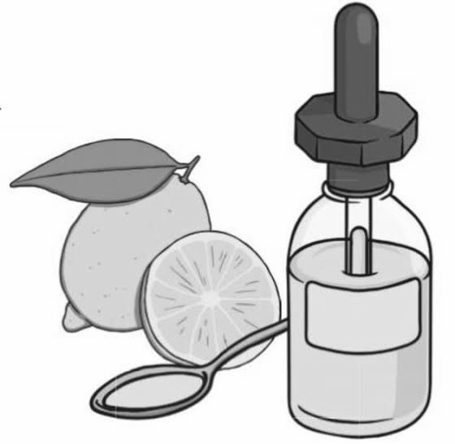
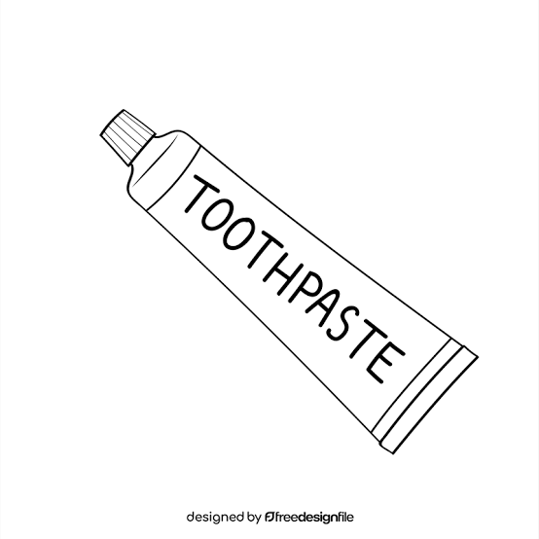
- b. c. c. d. Both b and c.

19. Which of the following combinations is a neutralisation reaction?
- Hydrochloric acid + Sodium hydroxide → Sodium chloride + Water
- Vinegar + Lemon juice → Citric acid + Acetic acid
- Sodium hydroxide + Soap → Salt + Water
- Lime juice + Baking powder → Carbon dioxide + Water

20. Study the given Venn diagram and identify X and Y.
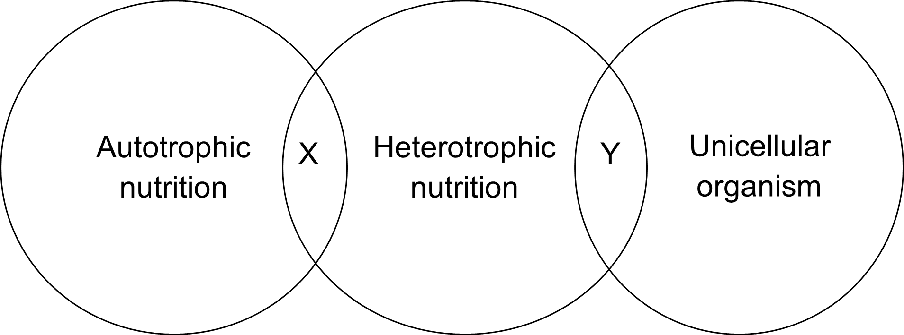

- X could be an organism that can fulfill its nitrogen requirement by feeding on insects and Y could be an organism that produces oxygen as a by-product of its food making process.
- X could be an organism such as fungus and Y could be a parasite.
- X could be an organism that can fulfill its nitrogen requirement by feeding on insects and Y could be an organism that is used in making bread such as yeast.
- X could be an organism such as lichen and Y could be a parasite such as Cuscuta.

21. The figure below shows a tray-warmer in which the candles are used as heaters.
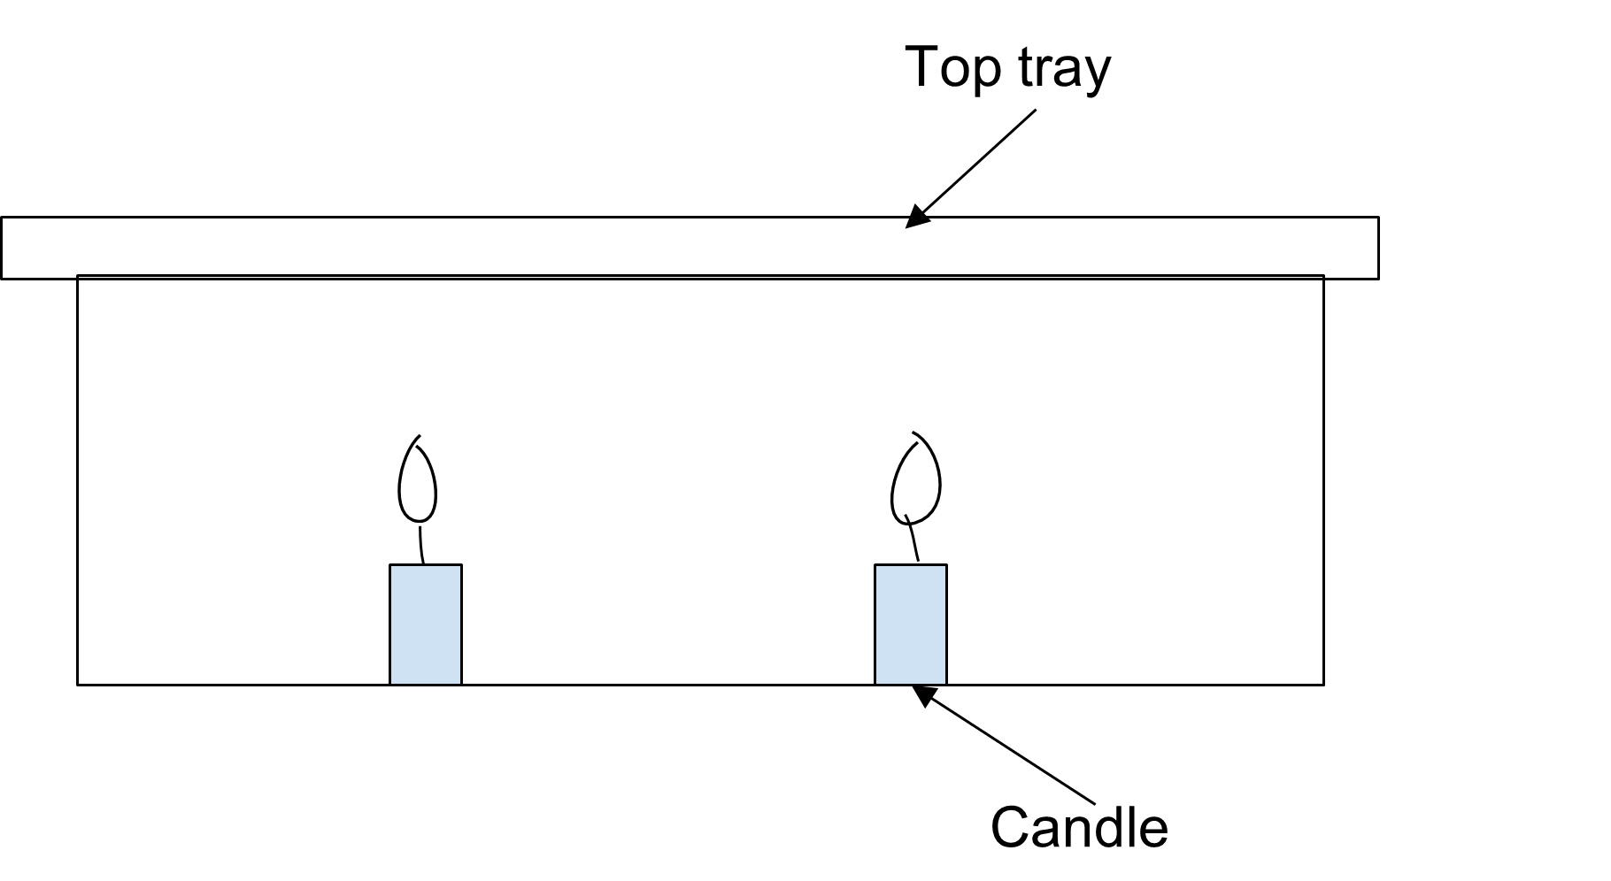

The flames of the candles do not touch the underside of the top tray, still the tray becomes hot. How does the heat pass to the top tray?
- Only by conduction.
- Mainly convection and some radiation.
- Mainly radiation and some conduction.
- Only by convection.

22. The figure below shows a vacuum flask and an enlarged view of a section through the flask wall. The main reason for the silver surfaces is to reduce heat transfer by -
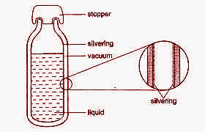
- Conduction only
- Conduction and convection
- Radiation only
- radiation and convection

23. When you touch a cold object -
- Heat flows from your body to the object
- Heat flows from the object to your body
- Temperature flows from your body to the object
- Temperature flows from the object to your body.

24. A plastic spoon is dipped in a hot cup of tea. The other end will-

- Remain cold
- Become hot due to convection
- Become hot due to conduction
- Both b and c

25. Which of the following is a strong acid?
- Nitric acid
- Citric acid
- Acetic acid
- Tartaric acid

26. Which of the following is NOT an acid- base indicator?
- Blue litmus
- Methyl orange
- Phenolphthalein
- Antacid

27. Assertion (A) : leguminous plants increase the fertility of soil.
Reason (R) : Leguminous plants have a symbiotic association with alga.
- Both A and R are true and R is the correct explanation of the assertion.
- Both A and R are true but R is not the correct explanation of the assertion.
- A is true but R is false.
- A is false but R is true

28. Assertion (A): Amla and lemon turn the colour of blue litmus paper to red.
Reason (R) : Amla and lemon are acidic in nature.
- Both A and R are true and R is the correct explanation of the assertion.
- Both A and R are true but R is not the correct explanation of the assertion.
- A is true but R is false.
- A is false but R is true

29. Which of the following features makes a clinical thermometer suitable for measuring human body temperature?
- It has a long, narrow uniform glass tube.
- It contains kink in the capillary tube to prevent mercury from falling back quickly.
- It can measure very high temperatures, up to 500°C.
- It does not require shaking after use.

30. Why is it recommended to rinse your mouth after eating food items with strong acids like tamarind or lemon?
- To neutralise excess acid and protect tooth enamel
- To clean the tongue
- To make the teeth shinier
- To reduce the sweetness of food

SECTION C

31. Describe the process of photosynthesis in green plants. Give a simplified equation for it. (2)

32. Why does a bee sting cause pain and how can a base help relieve it? (2)

33.Draw and label the structure of a stomata. (2)

SECTION D

34. The students were taken for a camp during their summer holidays. There were two types of tents, one made of black fabric and one of white fabric. They were told to choose the tents of their choice.
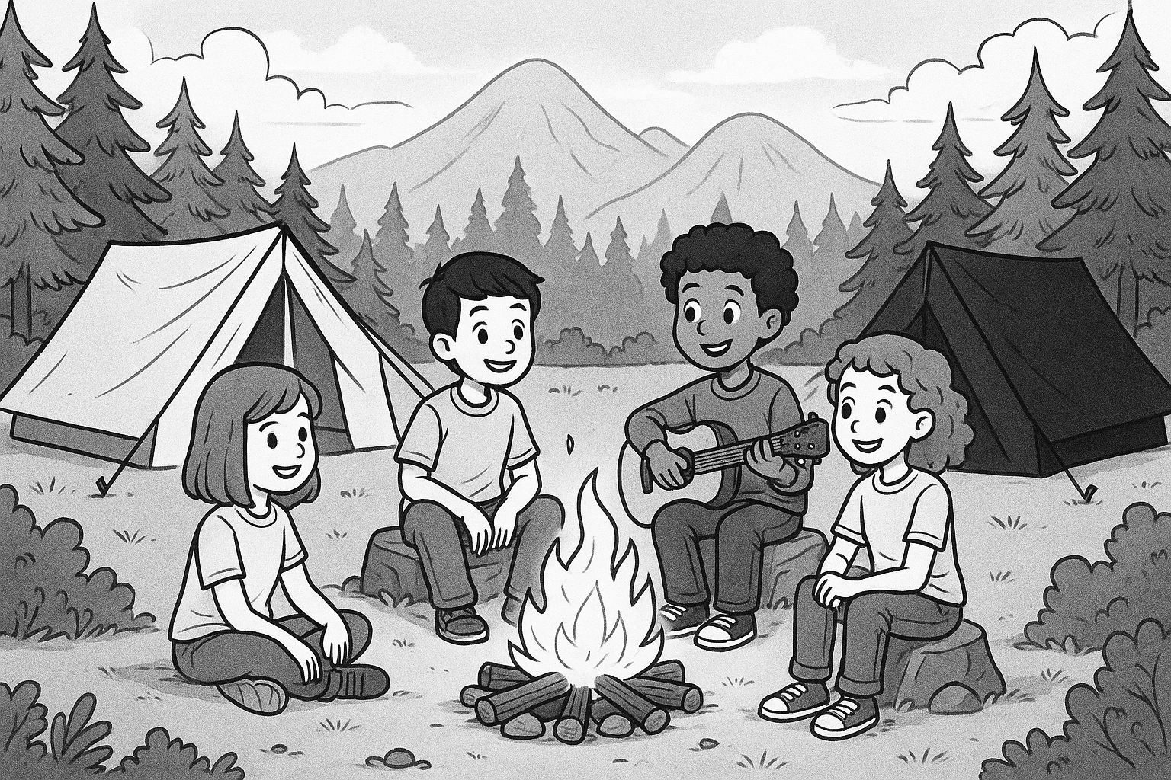

- Which colour of the tent should they choose now and why? Should they choose the same colour of tent for a winter camp? (2+1= 3)
- At night, the students gathered around the bonfire. Which mode of heat transfer was involved to make them feel warm? (1)

